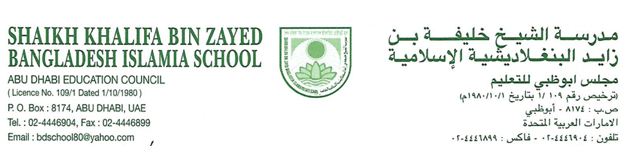
Student Code of Conduct Policy
2025-26

1. Purpose
The Student Code of Conduct Policy sets the behavioral expectations for all students enrolled at Shaikh Khalifa Bin Zayed Bangladesh Islamia School. It promotes a safe, respectful, and inclusive learning environment, grounded in the values of the UAE and in line with ADEK’s 2025 regulations.

2. Guiding Principles
This policy is guided by:
- Respect for UAE culture, religion, and heritage, including the Arabic language and Emirati traditions.
- Commitment to tolerance, inclusion, and mutual respect among students of all nationalities.
- Promotion of student wellbeing, positive behaviour, and restorative approaches to discipline.
- Alignment with ADEK’s Student Behaviour Management Framework (2025).

3. Expected Student Behavior
All students are expected to:

a. Demonstrate Respect
- Show respect to UAE national identity, values, and cultural norms.
- Uphold respect for all members of the school community including teachers, staff, peers, and visitors.
- Use courteous language and avoid all forms of disrespectful behaviour.

b. Maintain Personal and Academic Integrity
- Complete schoolwork honestly without cheating or plagiarism.
- Avoid lying, forgery, or manipulation of information.
- Abide by school policies related to examinations, homework, and group work.

c. Display Responsible Digital Behaviour
- Follow the school’s Cyber Safety and Social Media Policy.
- Avoid cyber bullying, online threats, or inappropriate digital content sharing.
- Use technology respectfully and only for educational purposes.

d. Respect the School Environment
- Keep school facilities clean and free of litter or vandalism.
- Use resources responsibly and with care.
- Refrain from damaging property or misusing school equipment.

e. Wear the School Uniform Proudly
- Follow the prescribed dress code and grooming standards at all times.
- Wear the uniform with pride, reflecting the school and UAE values.

f. Attend Punctually and Participate Actively
- Be present and punctual for all classes and school activities.
- Show active engagement in academic and co-curricular pursuits.
- Bring required materials and demonstrate preparedness.

4. Unacceptable Behaviors
Behaviors considered unacceptable and subject to disciplinary action include (but are not limited to):
- Physical aggression, fighting, or bullying
- Discrimination based on nationality, religion, race, or gender
- Possession or use of prohibited substances (tobacco, vape)
- Use of foul language or gestures
- Truancy or repeated tardiness
- Inappropriate use of mobile phones or electronic devices
- Involvement in theft or vandalism

5. Disciplinary Measures
Shaikh Khalifa Bin Zayed Bangladesh Islamia School follows a response model in addressing misconduct, including:
- Verbal or written warnings
- Parent-teacher/student meetings
- Restorative practice sessions
- Detentions or temporary suspensions
- Behaviour contracts
- Referral to ADEK in serious cases
All disciplinary measures aim to educate and correct behavior rather than merely punish.

6. Recognition of Positive Behaviour
The school actively promotes and rewards good behaviour through:
- Certificates of appreciation
- Verbal praise and classroom rewards
- Recognition in assemblies and newsletters

7. Upholding UAE Identity
Students are expected to:
- Stand respectfully during the UAE National Anthem.
- Participate in UAE National Day, Flag Day, and other cultural celebrations.
- Demonstrate tolerance and appreciation for Islamic values and national customs.

Policy Review
This policy will be reviewed annually or as required by ADEK regulatory updates. Stakeholders will be involved in the review process to ensure its continued relevance.

SCHOOL ADMINISTRATION

Review date: 01/01/2026

